CHAPTER 1: INTRODUCTION
1.1 Objective

Over populated Country like Bangladesh where population is increasing day by day, but every works on every sector is not digital yet .For that result sometimes we face different kinds of trouble where the works need to complete with adjustment of time.But we could not cause of lack of technological development.If we consider the educational system it will be a good example where we can say this is not updated yet. And on the educational site polytechnic institute are not capable enough to walk with our modern generation that’s why I proposed Online Student Result Management system of Polytechnic Institute which is fully automated and operates through internet. Using this system teacher can make an tabulation sheet through online and can print the student’s history and make online transcripts for a particular student.

1.2 Existing System
At present time people in Bangladesh like Teachers and students have become more conscious and are taking necessary steps to ensure that they have a digital technology to fulfil the print of tabulation sheet. – that is why everyday many student come to university for check-ups their update marks to the teacher. But in our country students spend a substantial amount of time in universities to get a marks sheet manually one by one teacher for a tabulation sheet. We observe that the main problem in Result management system at present time all polytechnic institute or Diploma course maintain their student serial manually. Particularly in most polytechnic institute facilities, daily marks sheet transactions are still done on paper.

1.3 Proposed System
The Proposed system of the project will emulate the existing paper based system of a polytechnic institute and it will help the student to make an marks sheet in online .The system allow the teachers to browse the students information. To make an marks sheet the teachers need to log in by using the User ID and Password, which are given during the registration on the website. It gives the opportunity to the admin to create user, delete user and to see the student list and it will increase the working performance all of the institute. A student can easily check his/her result details by using this system.

1.4 Methodology to be used for this project
Using this method a teacher can make marks sheet through internet using online result management system. Once the teachers finished their entries the information of that particular students will saved in the system database. An admin or teacher can retrieve that information from the server and also can get the whole student’s marks list. A teacher can make tabulation with the software and store history of the admitted students as well.
1.5 Aim of the project
Main aim is to develop an online result management system successfully, which will be a fully automated. The goal of this project is to make every task of the student and teacher about the marks sheet of the student much easier than the present system. This system will ensure that, the student can get their tabulation without any harassment.

CHAPTER 2: SYSTEM REVIEW

2.1 Online student result management system
Online doctor appointment management system is an automated web based application system. There is no need to install the application. All you have to need a web site, domain name and a host to upload the website. To make appointment or prescription the server gets the request from the user and saves or retrieves data from or to the database. And the required information will appeared in the browser window.

2.2 Accomplishment challenges

Accomplishment challenges are this type of task which is really difficult to overcome. But things can be solved. There are a lots of challenges came ahead to develop the online patient management system such as doctors availability, patients data collection, prescriptions data collection, to retrain the appointment system with the prescription making etc.

2.3 Benefits of the project

Using online doctor appointment management system, a patient can give online appointment without going to doctor’s chamber physically and also will get all information about a specific doctor. A doctor can also get the patients appointment list for each day and can make a prescription as well. Our online patient management system will be able to performed like

- Information about Student.
- Student admission.
- Semester/Department wise student list.
- Student marks entry by class teacher.
- Print Mark Sheet.
- Print Tabulation Sheet

2.4 Information about student
A student or general user can search over internet to get information about their result by using our online result management system. If a teacher enter the marks/total query about a student like which subject they want to see their result .It will be helpful for them to get the whole result. It is very easy and convenient to inquiry about their result, using this system without go to course teacher or college.
2.5 Student Admission
Student admission is the easiest way to admit without hassle. Using result management system a student can make online online admission with the desired subject he/she wants to admit. All they need a computer with internet connection to get this facility. And now a day’s internet connection is very economical in our country which is a vital point for our project.
2.6 Marks Entry by Class teacher
For using this system in the admin level, a user must be created or registered. To complete this task a general blank form needs to be filled with user information, Student ID and Information. A teacher can modify the entered data or information about them with the help of administration later. Administration has all the rights to delete any Student and create them.
2.7 Make Marks Sheet
nce the teacher finished to give their marks all information of students will store system database. When a teacher log in his/her account he/she can see all result each of single student .From that list if teacher want he/she can print any of them result or all of them.
2.8 Make Tabulation Sheet
Teacher can make tabulation sheet with the help of our online software tool. They do not need to write any entity of marks on the paper. All they have to do is select a format of the tabulation sheet and set the student id and technology and then click select. Online tabulation sheet making is very time saving and convenient for a teacher.

CHAPTER 3: TECHNOLOGIES USED IN THE PROJECT
3.1 Introduction
Our system is followed totally dynamic web based rule. In this system, we used some web programming language are HTML, CSS, JAVASCRIPT, and PHP, MySQL. If anyone interested in gaining practical and comprehensive insight into the PHP programming language and MYSQL database server and this prominent technologies can be used together to create dynamic, database driven web application, this project can be the great help for them.
3.2 HTML and CSS overview
HTML is the W3C standard for developing cross browser compatible web sites. It fuses all of the display elements of HTML with some of the functionality of XML. By forcing a web designer to program more carefully and adhere to strict code standards, HTML allows a larger percentage of browsers or code parser to properly parse your documents. In less geeky terms, it means more people can see your site the way you meant for them to see it, and less people see your site with elements strewn all over their page. CSS is the language for describing the presentation of Web pages, including colors, layout, and fonts. It allows one to adapt the presentation to different types of devices, such as large screens, small screens, or printers. CSS is independent of HTML and can be used with any XML-based markup language. The separation of HTML from CSS makes it easier to maintain sites, share style sheets across pages, and tailor pages to different environments. This is referred to as the separation of structure from presentation.

3.3 Introduction to the PHP Language and the OOP Concept
Encapsulation is the mechanism to bind data and actions and hide it from outside world.PHP class does the same.we have private, protected and public access to data members.We can restrict and use setter and getter methods to access them.Abstract class is to create a template so that all the sub classes should implement abstract methods or mark themselves as abstract.We can’t create objects for abstract classes.Abstract methods are methods definitions without implementations.PHP implements this using “abstract” key word,we can mark methods and classes as abstract.

3.3.1 PHP Language
PHP started out as a small open source project that evolved as more and more people found out how useful it was. Rasmus Lerdorf unleashed the first version of PHP way back in 1994.
- PHP is a recursive acronym for "PHP: Hypertext Preprocessor".
- PHP is a server side scripting language that is embedded in HTML. It is used to manage dynamic content, databases, session tracking, even build entire e-commerce sites.
- It is integrated with a number of popular databases, including MySQL, PostgreSQL, Oracle, Sybase, Informix, and Microsoft SQL Server.
- PHP is pleasingly zippy in its execution, especially when compiled as an Apache module on the Unix side. The MySQL server, once started, executes even very complex queries with huge result sets in record-setting time.
- PHP supports a large number of major protocols such as POP3, IMAP, and LDAP. PHP4 added support for Java and distributed object architectures (COM and CORBA), making n-tier development a possibility for the first time.
- PHP is forgiving: PHP language tries to be as forgiving as possible.
- PHP Syntax is C-Like.
Common uses of PHP
- PHP performs system functions, i.e. from files on a system it can create, open, read, write, and close them.
- PHP can handle forms, i.e. gather data from files, save data to a file, through email you can send data, return data to the user.
- You add, delete, modify elements within your database through PHP.
- Access cookies variables and set cookies.
- Using PHP, you can restrict users to access some pages of your website.
- It can encrypt data.
Characteristics of PHP
Five important characteristics make PHP's practical nature possible −
- Simplicity
- Efficiency
- Security
- Flexibility
- Familiarity
3.3.2 Object Oriented Programming Concept
Object Oriented programming is a programming style which is associated with the concepts like class, object, Inheritance, Encapsulation, Abstraction, Polymorphism. Most popular programming languages like PHP, Java C++, C#, Ruby, etc. follow an object-oriented programming paradigm. As PHP being the most sought-after skill, we will talk about object-oriented programming concepts in PHP. An object-based application in PHP is based on declaring classes, creating objects from them and interacting between these objects.
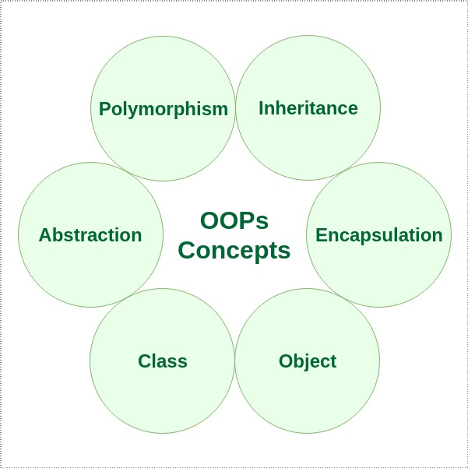
Figure 3.1: Object Oriented Programming Concept

3.4 INTRODUCTION TO PHPMYADMIN
3.4.1 What is SQL?
Structured Query Language (SQL) is a standard computer language for relational database management and data manipulation. SQL is used to query, insert, update and modify data. Most relational databases support SQL, which is an added benefit for database administrators (DBAs), as they are often required to support databases across several different platforms.
First developed in the early 1970s at IBM by Raymond Boyce and Donald Chamberlin, SQL was commercially released by Relational Software Inc. (now known as Oracle Corporation) in 1979. The current standard SQL version is voluntary, vendor-compliant and monitored by the American National Standards Institute (ANSI). Most major vendors also have proprietary versions that are incorporated and built on ANSI SQL, e.g., SQL*Plus (Oracle), and Transact-SQL (T-SQL) (Microsoft).
3.4.2 Why SQL?
- Allows users to access data in relational database management systems.
- Allows users to describe the data.
- Allows users to define the data in database and manipulate that data.
- Allows to embed within other languages using SQL modules, libraries & pre-compilers.
- Allows users to create and drop databases and tables.
- Allows users to create view, stored procedure, functions in a database.
- Allows users to set permissions on tables, procedures, and views
3.4.3 SQL Process
When you are executing an SQL command for any RDBMS, the system determines the best way to carry out your request and SQL engine Figureures out how to interpret the task.
There are various components included in the process. These components are Query Dispatcher, Optimization Engines, Classic Query Engine and SQL Query Engine, etc. Classic query engine handles all non-SQL queries but SQL query engine won't handle logical files.
Following is a simple diagram showing SQL Architecture:

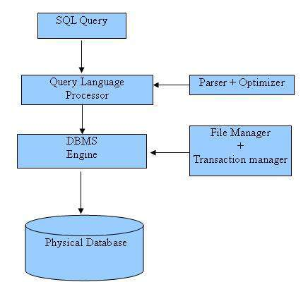
Figure 3.2: SQL Process

CHAPTER 4: SYSTEM USE CASE OVERVIEW

4.1 What is use case?
Use case diagrams are able to identify a set of actions that some system or systems should or perfume in collaboration with external user of the system. More specifically, a use case describes a sequence of actions that provided something of measurable value to an actor and is drawn as a horizontal ellipse. The most common parts of a use case are actor, association, system boundary and packages. Our online patients management system is consist of many subsystems and each one contains an individual use case. The subsystems are:

- Admin use case
- Teacher use case
- Make prescription.
4.2 Admin use case
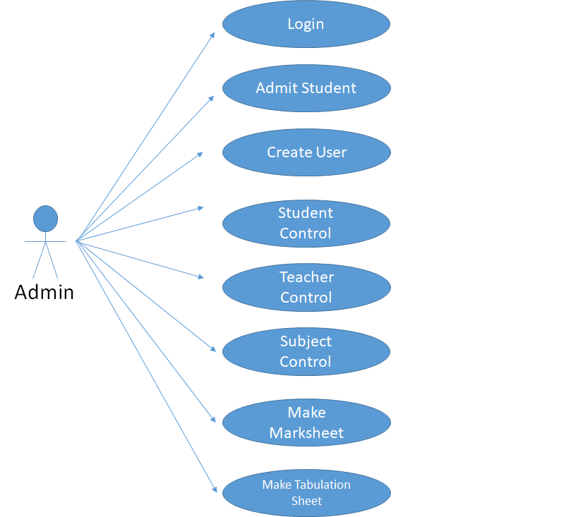
Figure 4.1: Admin use case

A admin can make an admission using this subsystem. Once the admission is confirmed in the system, a confirmation will be appeared on the screen which is print able.
Step by step description
1. Put the student’s name,Id,technology and address on the information fields.
2. Go to student control for giving subject for particular technology .
3. Then posting a teacher for that particular subject.
4. Wait for teacher’s marks entry.
5.Make marks sheet for individual student.
6.Print marks sheet.

4.3 Teacher use case
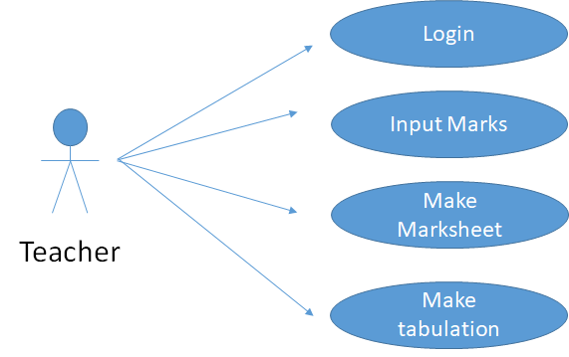
Figure 4.2: Teacher use case

In the system, after login teacher all the information of the students will see the teacher and according to performance teacher will enter students marks and according to performance teacher will make the tabulation.

Step by step description
1. Teacher needs to login.
2. Put all marks of student.
3. Make marks sheet for each of the student.
4. Make a Tabulation.

CHAPTER 5: DATABASE SYSTEM

5.1 Overview of database system

Database server consisting with a computer program and it provides database services to other computers; mainly depend on the client-server model. The term used to refer to the back-end system of a database application using server architecture. These back-ends sometimes called a database server. Database server performs tasks as data analysis, storage, data-manipulation, archiving, backup and recovery also. In this chapter, we will discuss about our system database server that is used for our project; we used SQL server for our project.
5.2 Advantage for using MySQL
My SQL is globally announced for being the most secure and reliable database management system used in popular web applications including WordPress, Drupal, Facebook and Twitter.MySQL offers unmatched scalability to facilitate the management of deeply embedded apps using a smaller footprint, even in massive warehouses that stack terabytes of data. On-demand flexibility is the star feature of My SQL.My SQL features a distinct storage-engine framework that facilitates system administrators to build the My SQL database server for a flawless performance. Whether it is an eCommerce website that receives a million queries every single day or a high-speed transactional processing system, My SQL is designed to meet even the most demanding applications while ensuring optimum speed, full-text indexes and unique memory caches for enhanced performance.
5.3 Online Student Result management database system
Our system is fully an online based system. It uses SQL; the total system developed with C Sharp and Sharp is very flexible with SQL database server. First we designed our total database structure that means, how many entity and attributes required for our system, and then we select the referential integrity and choose acridity. Finally we crate our total database system.

5.4 Total ERD for our system
The Final result of ER-modeling is called the ER-Diagrams (ERD). ER-modeling is a data modeling technique used in software engineering to produce a conceptual data model of an information system. Diagrams created using this ER-modeling technique are called Entity-Relationship Diagrams, or ER diagrams or ERDs. So you can say that Entity Relationship Diagrams illustrate the logical structure of databases. Dr. Peter Chen is the originator of the Entity-Relationship Model. His original paper about ER-modeling is one of the most cited papers in the computer software field. Currently the ER model serves as the foundation of many system analysis and design methodologies, computer-aided software engineering (CASE) tools, and repository systems.

5.5 Tables used in our system
This picture that is taken from our system database after creating all tables:-
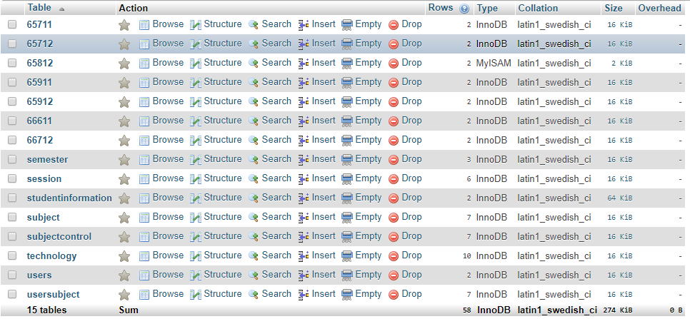
Figure 5.1: Total Database Table
In Figure shows, Total Fifteen table designed for online student result management system database. These are semester, session, studentinformation, subject, subjectcontrol, technology, users, usersubject and subject code table(65711,65712 etc) table.

5.6 Design and description of all total database table:-
5.6.1 User Registration table design
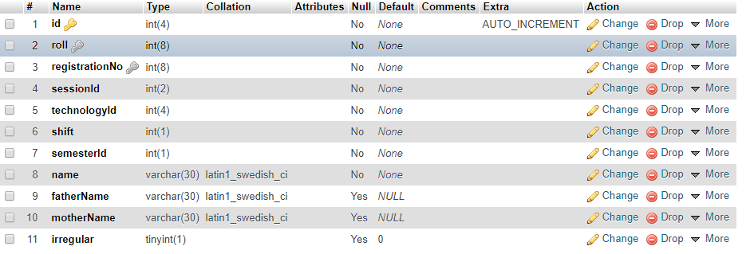
Figure 5.2: Student Information Table
In Figureure shows, this table is design for user registration. User can register the system by using their father-name, mother-name, Id, roll, registration number, technology,semester Id and session Id. All information will save system database and system will give a login id to login their course teacher account. After login the account teacher can make a tabulation sheet.

5.6.2 Technology Table:
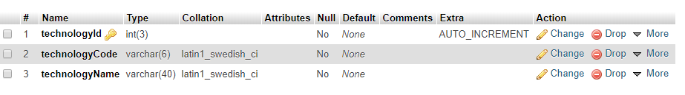
Figure 5.3: Technology Table

In Figureure shows the technology Id, code, name and its attributes. Technology table stores information about student’s technology of the system. Academic info table is needed to store all academic information about the employees in the creation of user and technology table store all technology related information.

5.6.3 Session table:
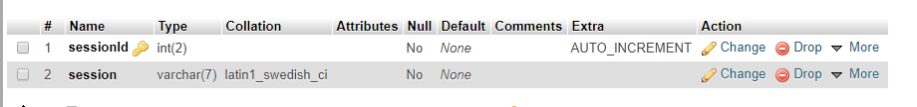
Figure 5.4 : Session Table
In Figurer shows the session Id, session period student profile info entity and its attributes as well as. User table stores all information of all users of the system, user profile saves all the user brief history like student Id, their session and session profile table is needed to ensure a student when the student come to admit to the particular academy.
5.6.4 Semester Table
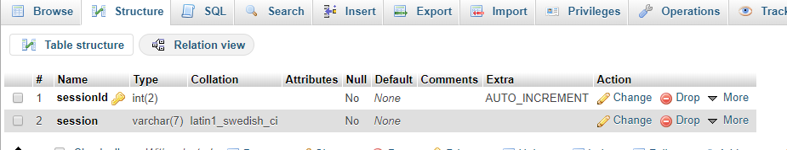
Figure 5.5: Semester Table
In this Figureure show the semester Id, semester date and semester path as well as. Here semester table store all semester name and semester path the create a session id against semester name.There is a close connection between semester and session table.
5.6.5 Subject Table
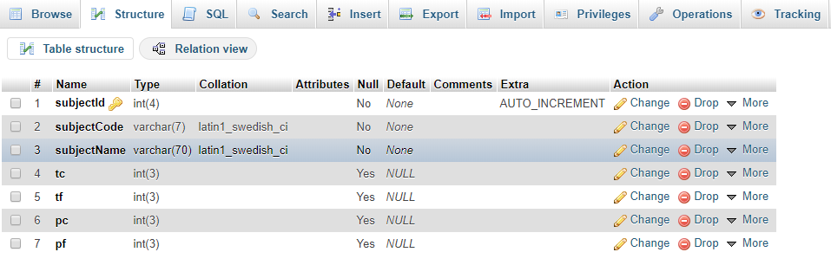
Figure 5.6: Subject Table
In this Figureure show the subject Id, subject_code and subject_name, tc, tf, pc, pf as well as. Here, subject table sore subject_ID,code,name and its marks individual from subject_table. All column are return int data type.
5.6.6 Subject Control Table 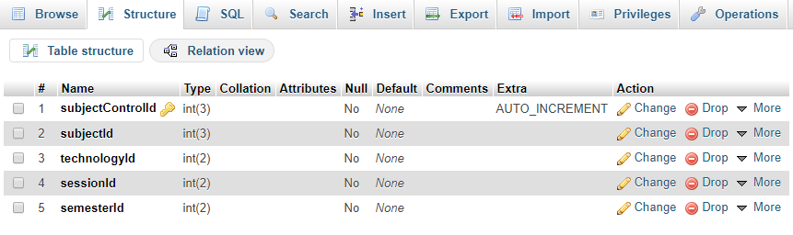
Figure 5.7: Subject Control Table
In this Figureure show Subject control table which is actually controlled by admin.where the subject control table includes all the types of needed which is essential such as subject_control_Id, subject_id, technology_id,session_id and semester_id. When teacher or admin login website. Then put user name and password from database.And it will show all the details of a student.
5.6.7 User Table
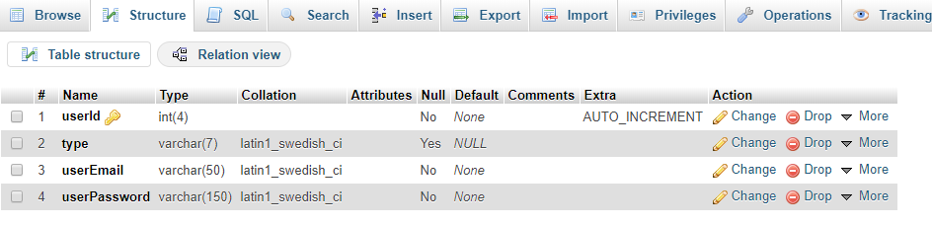
Figure 5.8: User Table
In this Figureure show User Id ,Type ,User email and User password . When any user (admin or teacher) login this system. If any teacher login the system , then his/her user role is teacher and any teacher login the system , then his/her user role is admin. When admin login system her/his show menu different.

5.6.8 User Control Table
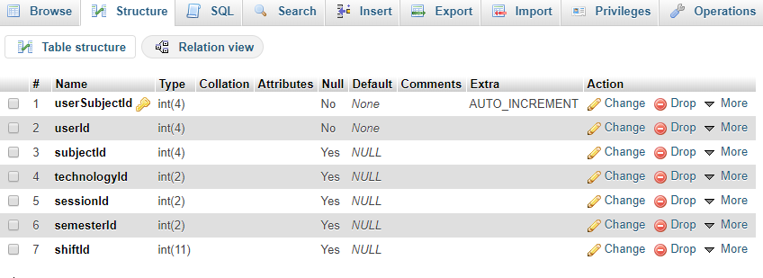
Figure 5.9: User Control Table
In this Figureure show User subject Id, User Id, Subject Id, Technology Id, Session Id,Semester Id and Shift Id. When any teacher wants to print tabulation for any student then all information will gather a tabulation sheet for a particular student.
5.6.9 Subject Code Details
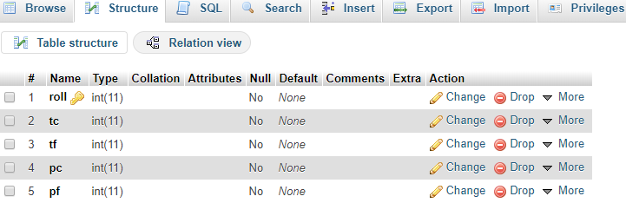
Figure 5.10: Subject Code Details
In this Figure show Roll,Tc, Tf, Pc, Pf which is include to subject control unit. Teacher put the acquire marks on that particular sector then save the data for students details table. If one or more marks are similar for one student then save different line but same student roll.

CHAPTER 6: DEVELOPMENT AND TESTING
6.1 Overview of development and testing
In this section; we will describe our total development process as well as the screenshot. First we design our total system, and then we designed our database system. Implementation is a very challenging task. As each module has described, it is must be checked out to remove any errors that means all demo design are tested. The Demo modules are then assembled to integrate to the real form of the system. When the integration is finished, the total system is being tested. Testing is one of the most important parts for a system or software. Testing the behaviour of the whole software/system as defined in software requirements specification (SRS) is known as system testing, its main focus is to verify that the customer requirements are fulfilled. System testing is done after integration testing is complete. System testing should test functional and non functional requirements of the software.

6.2 System testing hierarchy
As with almost any technical process, software testing has a prescribed order in which things should be done. The following is a list of software testing categories arranged in chronological order. These are the steps taken to fully test new software in preparation for marketing it:
- Unit testing – testing performed on each module or block of code during development. Unit testing is normally done by the programmer who writes the code.
- Integration testing – testing done before, during and after integration of a new module into the main software package. This involves testing of each individual code module. One piece of software can contain several modules which are often created by several different programmers. It is crucial to test each module’s effect on the entire program model.
- System testing – testing done by a professional testing agent on the completed software product before it is introduced to the market
6.3 Total system for the admin/teacher
This is our Home page, when any teacher visits through this page he/she can know about our system, our services, about us, contact us.After making an appointment of a teacher he/she need to register in our system. After registration he/she will able to login by using email id and password. She/he can make an entity of marks of student for particular subject, gather information about our result and can print tabulation sheet about each of the single student.
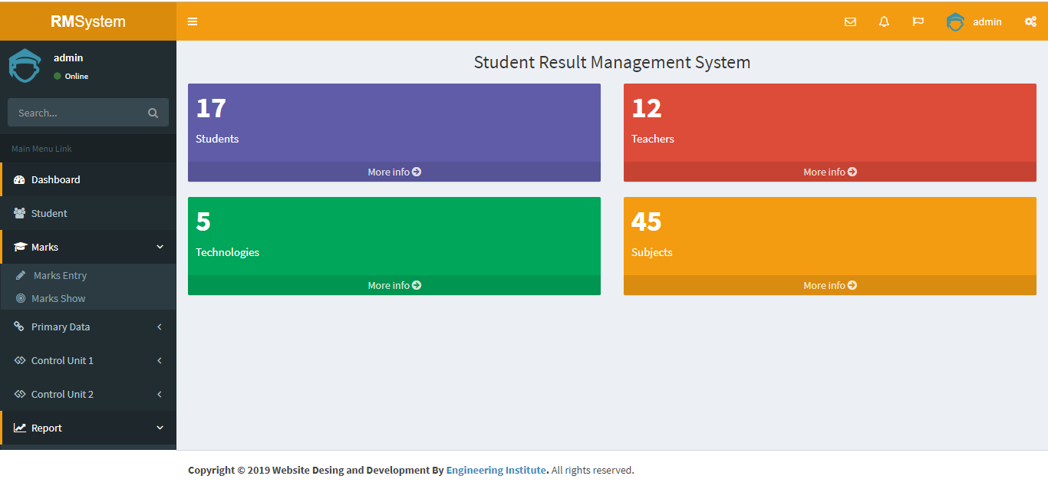
Figure 6.1: Home Page

6.3.1 Online Student Registration
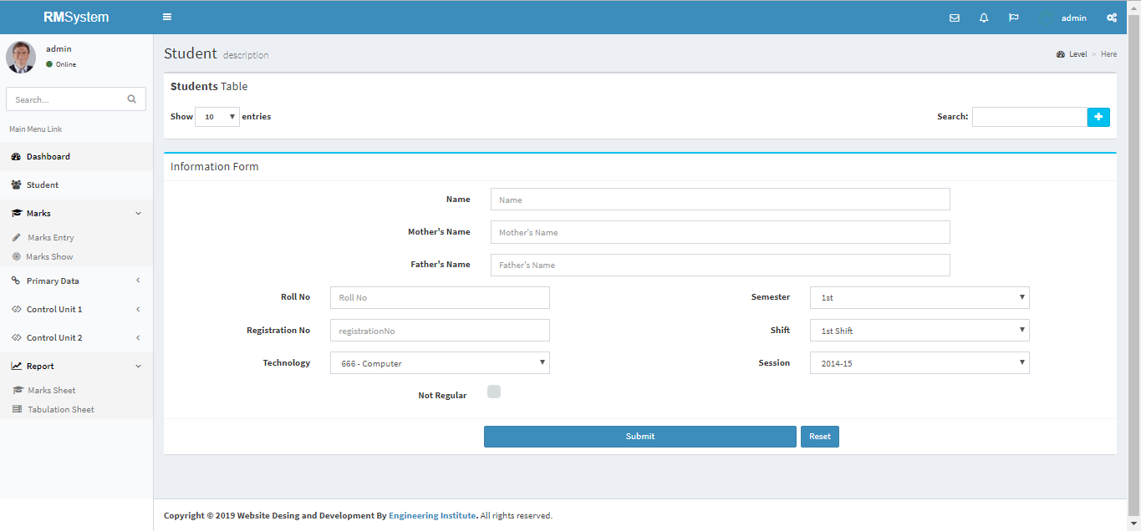
Figure 6.2: Online Student Registration Page

6.3.2 Student Information
All the students information will gather for a several purpose.For each of single student with proper identification there have 10 entities.For register each of them they must have to do several entity which will represent a student when we want to know about his/her semester result.Thus the all processing system will save all the students information will gather our database when we want to print their result this all entities will show.That is how we can maintain our details with proper security.
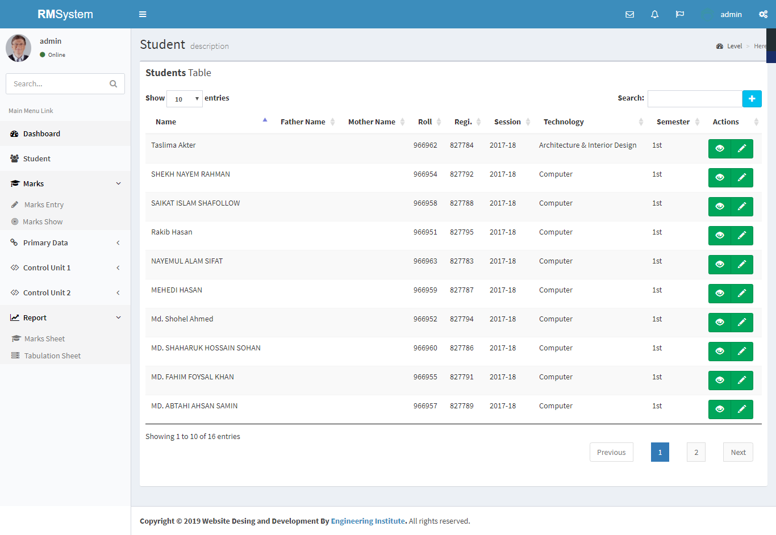
Figure: 6.3: Student Information Page
6.3.3 Technology Page
By visiting our technology page user can entry any technology which the admin whats to do provide for the teachers and students.
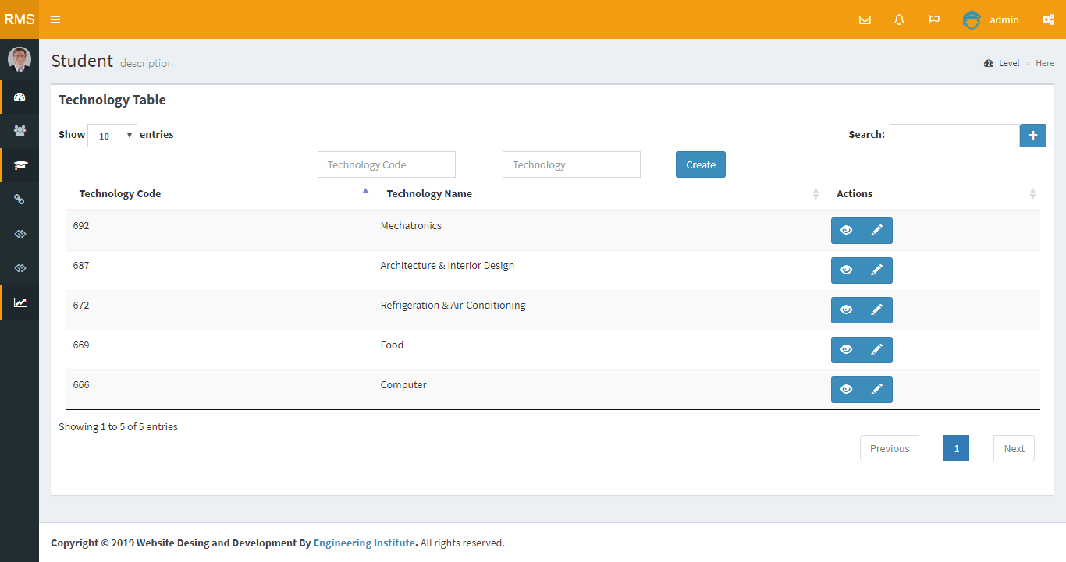
Figure 6.4: Technology Page

6.3.4 Session Overview
From session table we can see there are 5 sessions 2014-2020.this session is very important for admin and teacher cause when they add student,subject or technology they must have to fulfil the session section otherwise the database wont show the details of particular student marks cause each semester is separated from other and their couse teacher too.Teaches appointment is also dependent on this session.
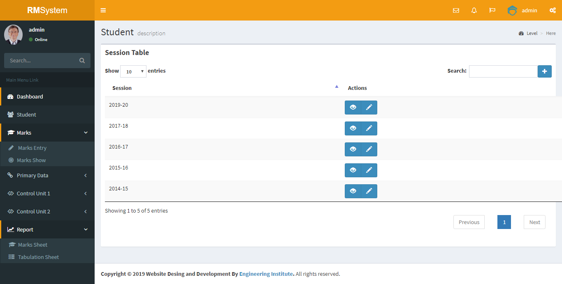
Figure 6.5: Session Overview

6.3.5 Subject Overview
For subject overview we can see which subject we added for the courses ,their name and the subject code also.we will see the TC, TF, PC, PF from the subject overview. 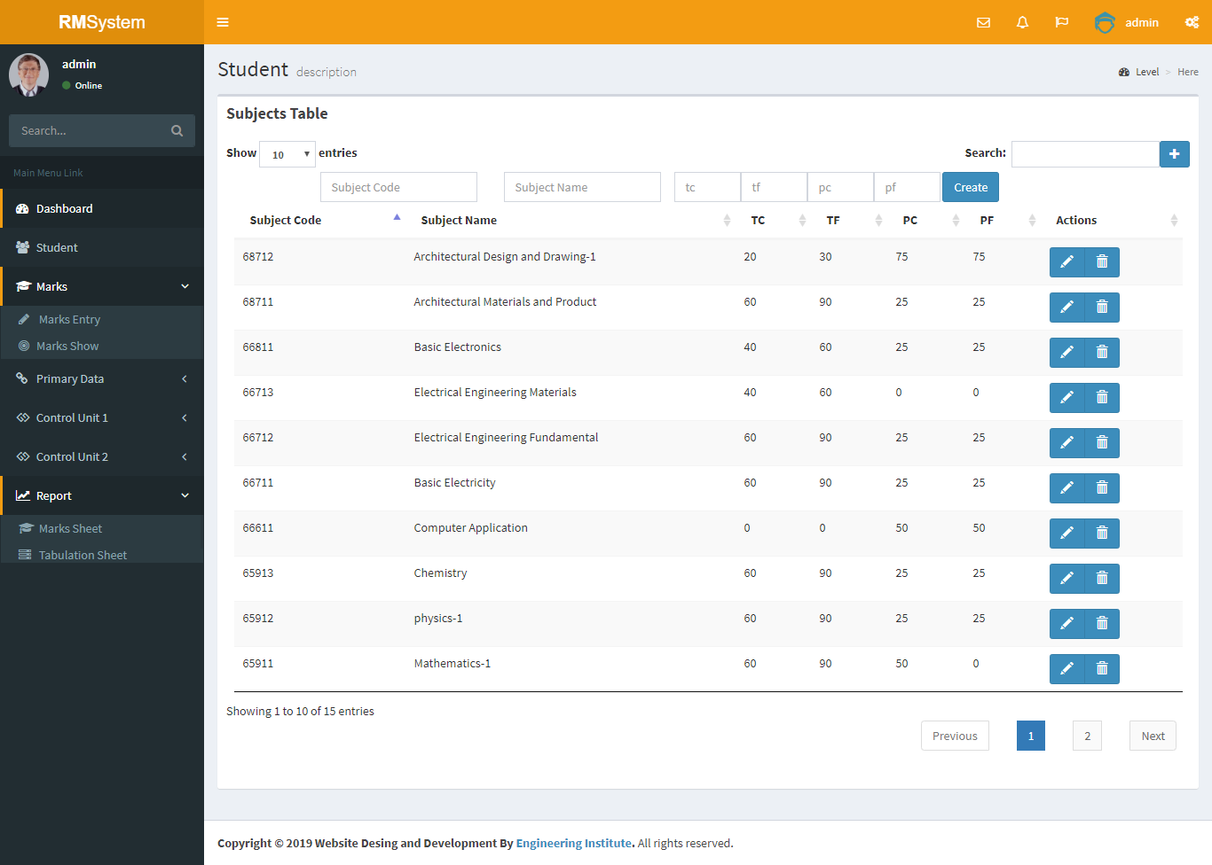
Figure 6.6: Subject Overview
6.3.6 Semester Overview
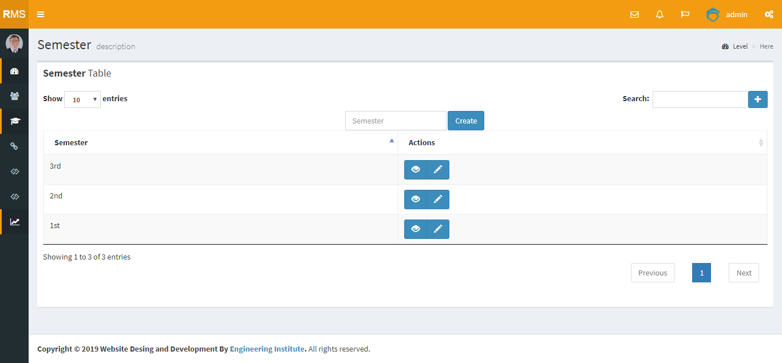
Fig 6.7: Semester Overview

6.4.1 Subject Control
For subject control admin have to go subject table there a
re several option that need to fulfil .For individual subject there have a subject code then he/she has to fill up which technology is prefer for the subject ,important sector is session .Admin need to mention the session and semester.he/she can add subject as much as he/she want.
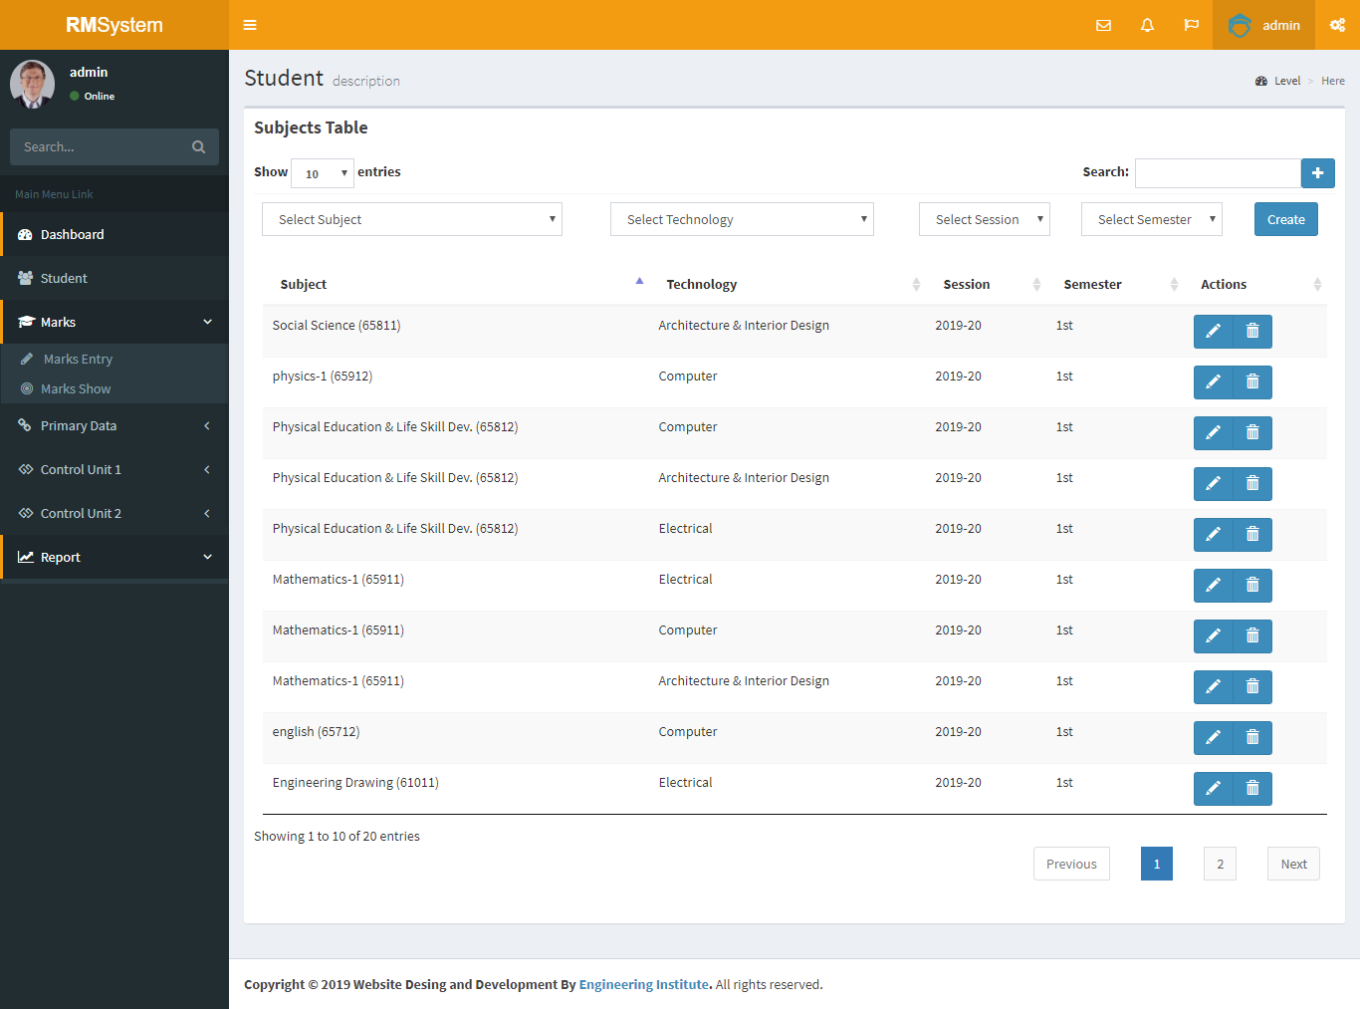
Figure 6.7: Subject Control

6.4.2 Teacher Control
In this table admin will give the responsibilities to the particular teacher which subject they are recommended.Admin will give the subject to the expert on that subject.
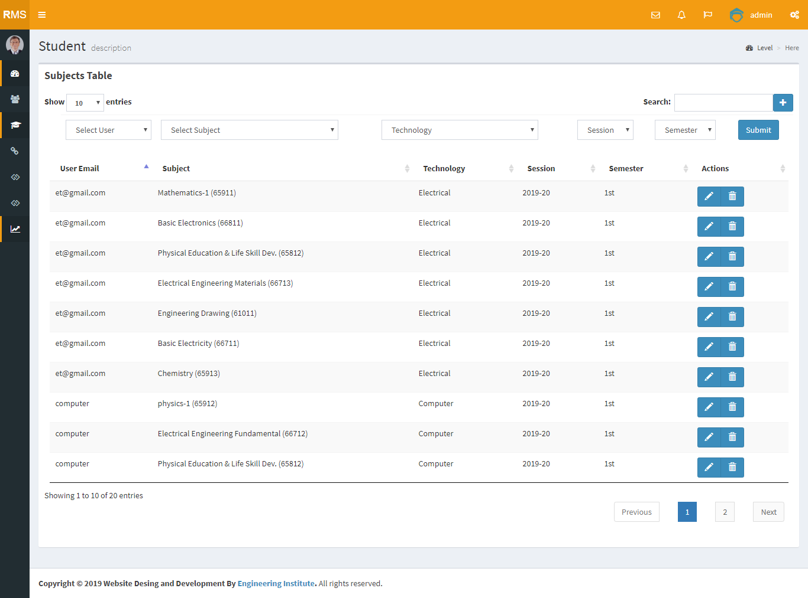

Figure 6.8: Teacher Control

6.4.3 Create User
Creating user means admin appointment teacher as a user.There are two types of user one is Admin and another is Teacher.Here the select type admin need to mention type as teacher ,then put a user email as regarding as teacher’s email and password.Teacher can login the site by using their User Id and Password.
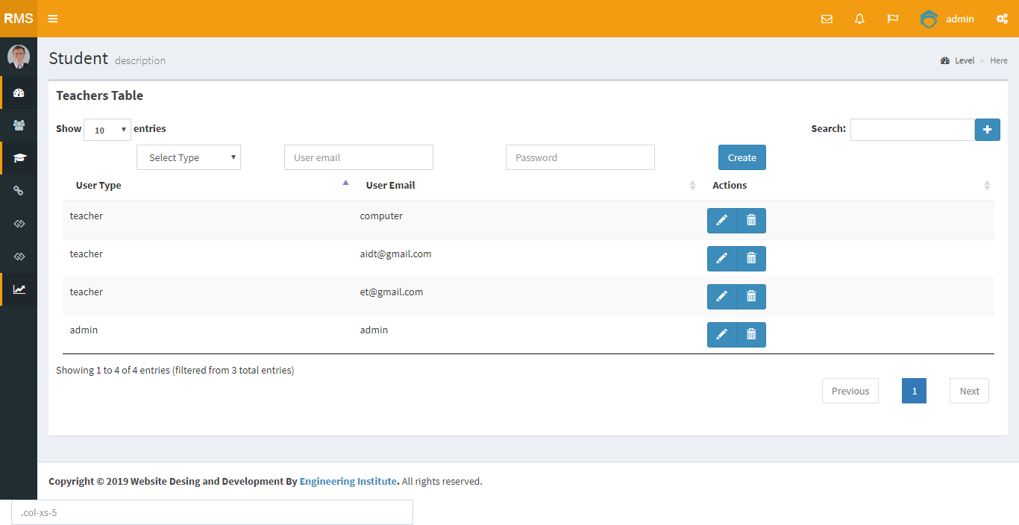

Figure 6.9: Create User

6.4.4 Admin/Teacher Login
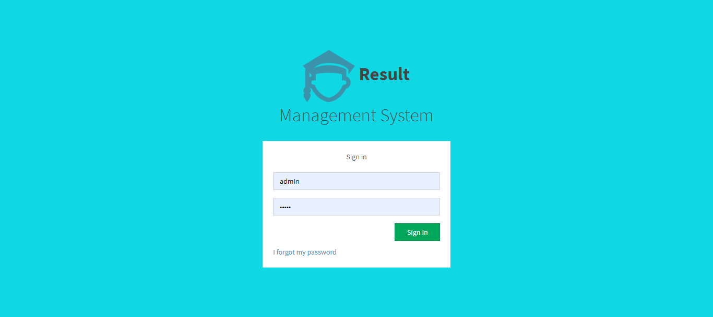

Figure 6.10: Admin/Teacher Login

6.4.5 Marks Entry
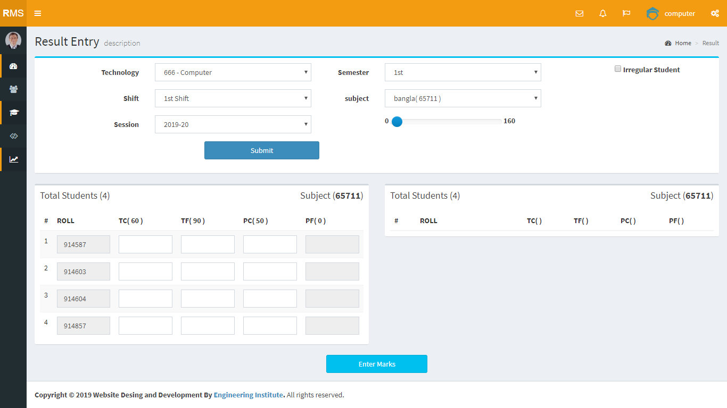

Figure 6.11: Marks Entry

6.4.6 Make Mark sheet:
Only Teacher can make mark sheet .For those he/she need to mention the technology,shift,session,semester and subject and he/she must have to mention that about a student that he/she is regular or irregular.After completing these procedure Teacher have to enter the marks of TC, TF ,PC ,PF.After completing all the required subjects marks which was taken by student it will not able be change again by teacher .Online tabulation making form like the followings-
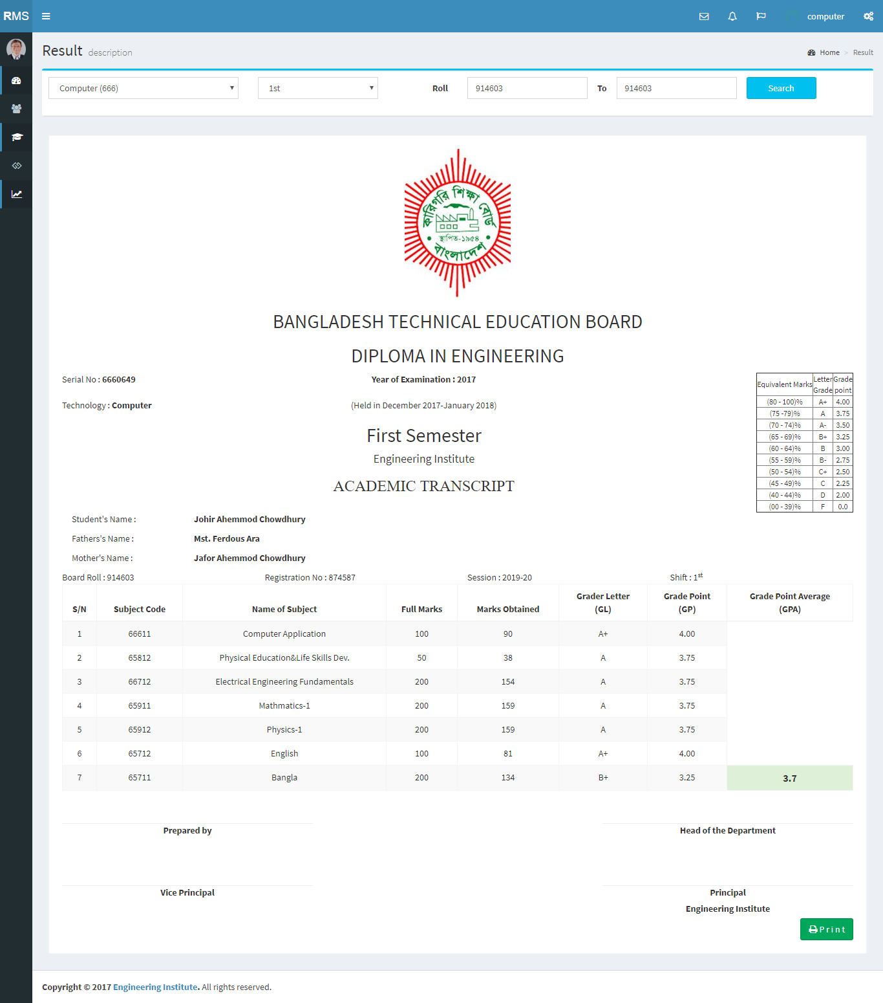
Figure 6.12: Make Mark sheet
6.4.7 Make Tabulation Sheet
Only Teacher can make mark sheet .For those he/she need to mention the technology,shift,session,semester and subject and he/she must have to mention that about a student that he/she is regular or irregular.After completing these procedure Teacher have to enter the marks of TC, TF ,PC ,PF.After completing all the required subjects marks which was taken by student it will not able be change again by teacher .When all the course marks will submit teacher or admin can print out of the particular student tabulation . Online tabulation making form like the followings-
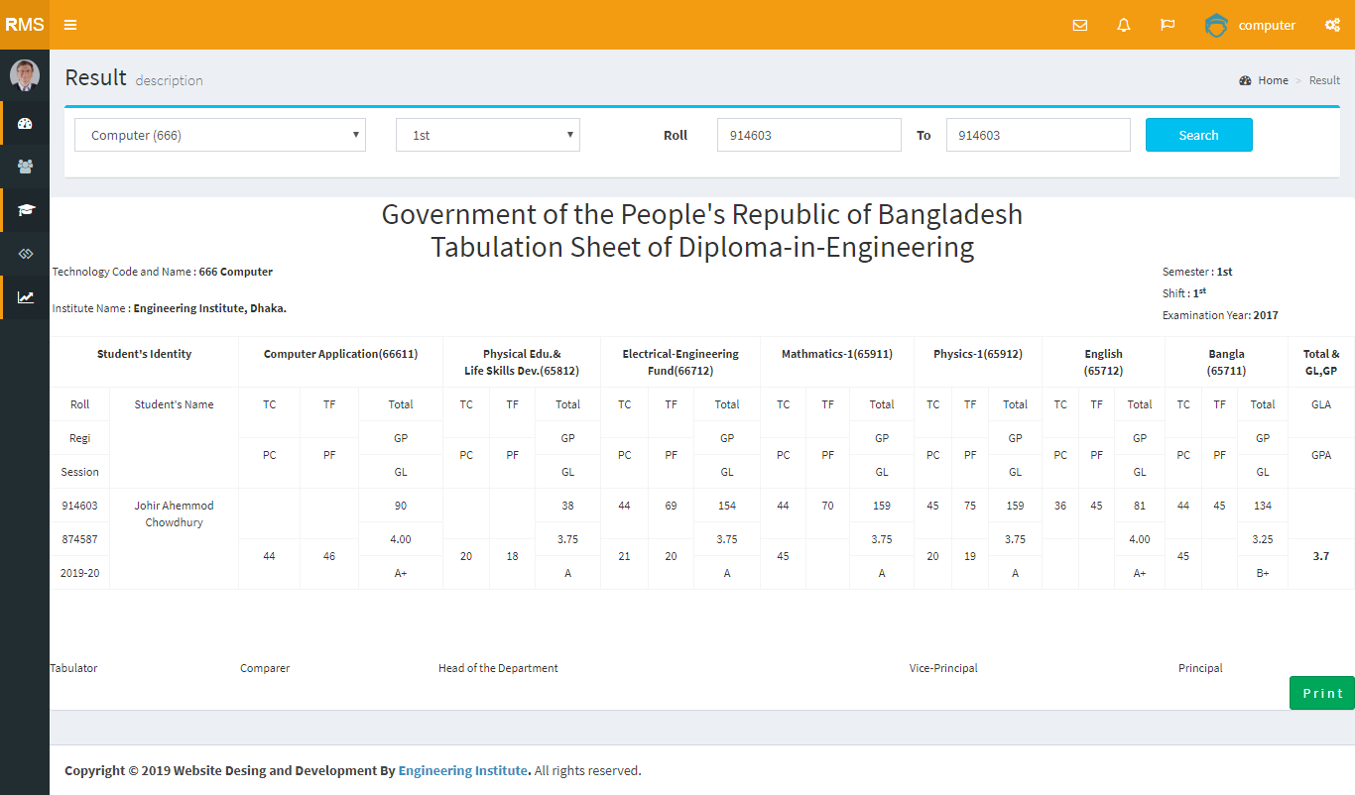
Figure 6.13: Make Tabulation Sheet

6.5 Input/Output testing for our system

We tested our system by submit data and saw the output of given data. We tested every component of our system by follow this method. The result of the test is the followings-

We tested our all pages of database by submit data. All fields are capable to work. In the contact page after filling the all information it publishes all the database what given

We also tested our admin login system in this way. All the fields are worked properly. Admin can able to create the user and show user list, teacher can able to make marks sheet and save it, then print the marks sheet.

User can also capable to register the system and after login the account he/she can make an tabulation and view the all information of students.

Our total system is fully verified and tested by inserting the value/all information. So, we can say that our system is working well as it designed and developed.

6.6 Summary
This is the most important chapter of this documentation. Here, the total system implementation is discussed. In another part, we discussed about the system testing and its approach. We also give here the real system’s screen shoots. That is very helpful to understand the total approach of our system. In the future we will develop our system for the client need basis. Now we are waiting for taking the feedback from our client.

CHAPTER 7: CONCLUSION
7.1 Goal
The goal of my project is to improve our result management system cause Bangladesh Technical Education Board (BTEB) Permitted Diploma In Engineering has 1st,2nd & 3rd term exam hold by its own institution and they have to build its own results.Each institute directs almost 5-15 technologies.Each technology has 3 terms.Each term has 7 subject and each subject has to give marks 4 different ways.If this process works manually this will be so lengthy.
Its a system develop where we can do all this process within a minute.

7.2 Limitations
There are few limitations for applying our proposed system, there are lots of synchronized process are going through such as students login,check the live result by students,updated notice which will be useful for every student so that student can maintain or become more careful about his/her result.This is essential cause if they can see their performance they will be serious about their study.

7.3 Future development
- Other related features will be developed in the future.
- The overall system introduces result support facilities to reduce some of the problems faced in general by teacher or authority and to provide the digital result management system of diploma polytechnic institute of Bangladesh.
- Online result management system will be more popular and easy to use.
7.4 Conclusion
In the modern world, there is no doubt that the web page is most important for any small or big organization. Now a days we depends on the web sites very much for everything like advertising, buying goods, searching jobs etc. A right web site can fulfill the users demand. It is more important for the users, that they can visit right web site for right information. There are lots of web sites in worldwide. The web site we developed is for individual requirement of the specific company and their clients. This developed system is suitable for any polytechnic institute where the total processing system worked by manually but by doing these all the works will be easy for both the teacher and organigation. The platform we used in our developed system is HTML, CSS, JQuery, PHP and SQL. In the purpose of the future use the website can be altered according to the organizations needs. And also able to add more features on the sites and remove from the sites. The intention of us to take this project is to improve the infrastructure of our polytechnic institute which is much neglected in our country. Our steps is very small to implement the online result management system but we hope one day we will contribute on educational area enormously and our developed system will be the great inspiration for all of IT professional who wanted to contribute in our education sector.

REFERENCES

[1]Thomas Powell “HTML & CSS The complete reference” 5th edition, Publisher Mc graw hill, published year 2010. pp.55-60,429-438.

[2] Don Gosselin “ASP.NET Programming with C# & SQL Server” Copy Edition, Publisher Cengage learning Inc, Published year 2009. pp.69-81, 365-410.

[3]Learn about w3schools, available at<< http://www.w3schools.com/html/default.asp>>, Last accessed on 03-02-2016 at 9.30am.

[4]Learn about w3schools, available at<< http://www.w3schools.com/css/default.asp >>, Last accessed on 03-02-2016 at 9.50am.

[5]Learn about w3schools, available at<< http://www.w3schools.com/php/default.asp >>, Last accessed on 05-03-2016 at 8.00pm.

[6]Learn about Html, available at<< http://html.net/tutorials/php/ >>, Last accessed on 10-03-2016 at 4.30pm.

[7]Learn about coderhousebd, available at<< http://coderhousebd.com/php-mysql-tutorial.php >>, Last accessed on 13-04-2016 at 10.30pm.

[8]Learn about UML-diagrams, available at<< http://www.uml-diagrams.org/use-case-diagrams.html >>, Last accessed on 13-05-2016 at 10.30pm.

[9]Learn about tutorialspoint, available at

<< https://www.tutorialspoint.com/asp.net/asp.net_database_access.htm >>, Last accessed on 21-06-2016 at 4.15pm.

[10]Learn about wikipedia, available at<< http://en.wikipedia.org/wiki/Database _serve.html >>, Last accessed on 13-07-2016 at 12.30pm.

[11]Learn about webopedia, available at<< www.webopedia.com/TERM/D/database_server.html >>, Last accessed on 2513-07-2016 at 6.00pm.

[12]Learn about ehow, available at<< http://www.ehow.com/list_6121487_advantages-relational-database- managementsystem.html >>, Last accessed on 1-08-2016 at 8.30pm.

[13]Learn about tutorialspoint, available at<< http://www.tutorialspoint.com/sql/sql-overview.htm >>, Last accessed on 10-08-2016 at 6.35pm.

